R081: Mood boards and Visualisation Diagrams

Name:

|  |  |  |
| --- | --- | --- |
| **A** | | **Mood boards: Content** |
| 1 | **Images** | |
| 2 | **Colours** | |
| 3 | **Colour schemes** | |
| 4 | **Fonts** | |
| 5 | ***Graphics*** | |
| 6 | *(digital only)* **Sound** | |
| 7 | *(digital only)* **Video** | |
| 8 | *(physical only)* **Fabrics** | |
| 9 | *(physical only)* **Materials** | |

|  |  |
| --- | --- |
| **B** | **Mood boards: Purpose** |
| 1 | *Generation* of ideas |
| 2 | *Development* of ideas |
| 3 | Communication of ideas with clients or colleagues |
| 4 | Creating a mood or feel |

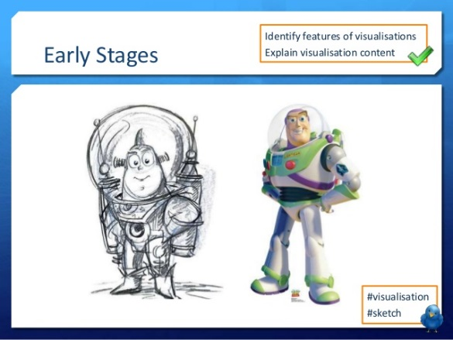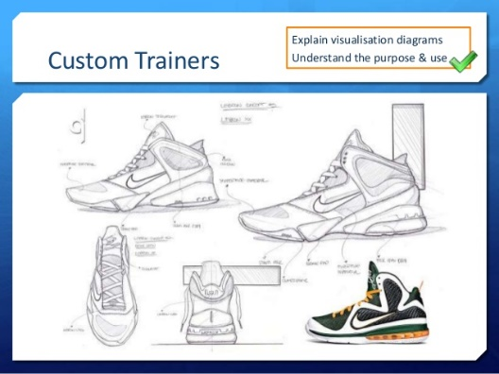

|  |  |  |
| --- | --- | --- |
| **D** | | **Visualisation Diagrams: Content** |
| 1 | **Drawn images** | |
| 2 | **Different viewpoints** (eg bird’s eye, plan etc) | |
| 3 | **Graphics** (eg logos, barcodes etc) | |
| 4 | **Layout** | |
| 5 | **Font** and style of text (not necessarily the content) | |
| 6 | **Annotations** showing details (eg size, interactivities, colours etc) | |

|  |  |  |
| --- | --- | --- |
| **F** | **Visualisation Diagrams: Key Vocab** | |
| **Graphics** | | Images made of simple shapes and colours |
| **Layout** | | The way parts of something are arranged |
| **Interactivity** | | The way something reacts with something else (eg what a button would do on a webpage) |

|  |  |
| --- | --- |
| **E** | **Visualisation Diagrams: Purpose** |
| 1 | Show how a finished item may look |
| 2 | Plan layout of a product visually |
| 3 | Show actions or interactivity |

|  |  |  |
| --- | --- | --- |
| **C** | **Mood boards: Key Vocab** | |
| **Generation** | | Creation |
| **Development** | | Gradual improvements |
| **Physical** | | On paper |
| **Digital** | | On screen |

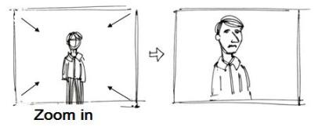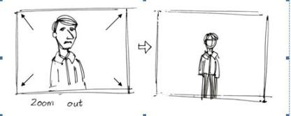

|  |  |  |
| --- | --- | --- |
| **B** | | **Story boards: Purpose** |
| 1 | Show how a moving visual product will look | |
| 2 | Help to plan camera positions, scenery, setting and props in production | |

|  |  |  |  |
| --- | --- | --- | --- |
| **A** | | | **Story boards: Content** |
| 1 | **Camera Shots** | | |
| 2 | **Camera Angles** | | |
| 3 | **Camera Movements** | | |
| 4 | **Scene content** (what’s happening) | | |
| 5 | **Annotations** (showing…) | | |
| 6 | | **Timings** | |
| 7 | | **Lighting effects** | |
| 8 | | **Sound effects** | |
| 9 | | **Location** | |
| 10 | | **Camera Type** | |

Name:

R081: Story boards

|  |  |  |
| --- | --- | --- |
| **C** | **Camera Vocab** | |
| **Camera Shots** | | |
| **Establishing shot** | | Wide angle including characters and setting |
| **Two shot** | | Shot including two characters in dialogue |
| **Close up** | | Shot of one character’s whole head |
| **Extreme close up** | | Shot of a particular detail (should be used sparingly) |
| **Camera Angles** | | |
| **Low angle** | | Shot from below, looking up at a character |
| **High angle** | | Shot from above, looking down at a character |
| **Mid angle** | | Shot showing the upper body and head of a character |
| **Wide angle** | | Shot including the whole body of a character |
| **Over shoulder** | | Shot with the back of a character’s shoulder and head in the foreground, putting the viewer in the scene |
| **Point of View** | | (normally hand held) shot as if the camera is the eyes of a character, putting the viewer in the position of the character |
| **Camera Movements** | | |
| **Zoom in** | | Camera stays still, but the image gets bigger |
| **Zoom out** | | Camera stays still, but the image gets smaller |
| **Pan** | | Camera stays still, but twists left or right |
| **Camera Type** | | |
| **Still** | | A still shot would not be moving |
| **Video** | | A normal moving image |
| **Virtual** | | An animated image |

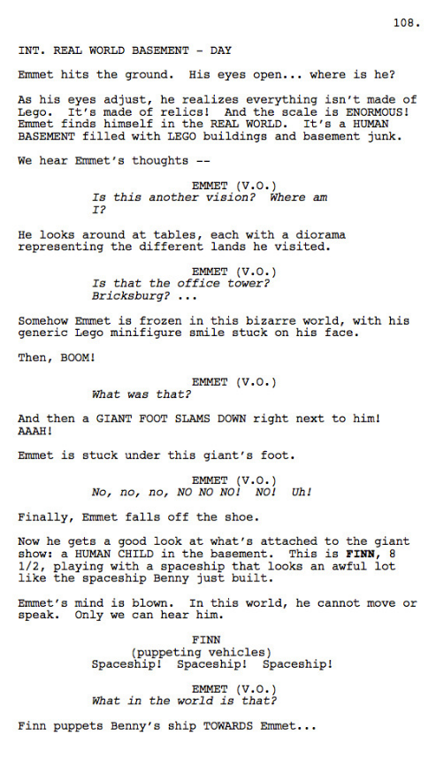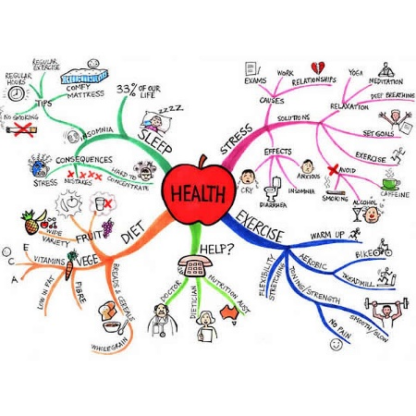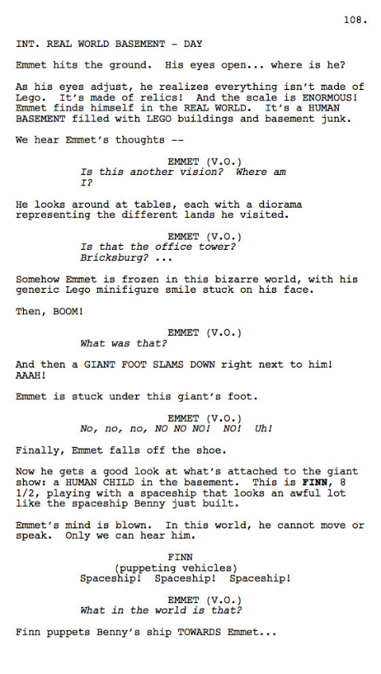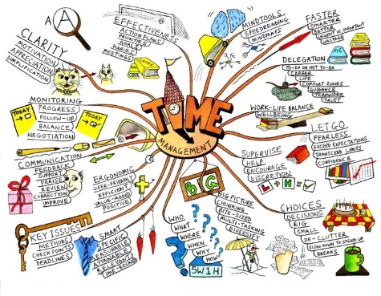

Name:

R081: Scripts and Mind Maps

|  |  |  |
| --- | --- | --- |
| **C** | **Scripts: Key Vocab** | |
| **Audio** | | To do with sound |
| **Audio-visual** | | Combining sound and pictures (ie films) |
| **Formatting** | | How the words are presented on the page |
| **Indentation** | | Set in from one side of a page |
| **Dialogue** | | Talking between characters |

|  |  |  |
| --- | --- | --- |
| **A** | | **Scripts: Content** |
| 1 | **Dialogue** | |
| 2 | **Stage directions** | |
| 3 | **Sound effects** | |
| 4 | **Names and details of characters** | |
| 5 | **Music or ambient sound** | |
| 6 | **Location** | |

|  |  |  |
| --- | --- | --- |
| **B** | | **Scripts: Purpose** |
| 1 | Show the dialogue and delivery directions for actors | |
| 2 | Indicate sound effects and scene requirements for production crew | |
| 3 | Outline of a production for clients, advertisers or any other stakeholders | |

|  |  |  |
| --- | --- | --- |
| **D** | | **Mind maps: Content** |
| 1 | **Central *node* with main theme** | |
| 2 | ***Sub-nodes* with related *general* ideas** | |
| 3 | **Sub-sub-nodes with *specific* ideas** | |
| 4 | ***Links* between nodes** | |
| 5 | **Text to show ideas** | |
| 6 | Sometimes **Images** | |

|  |  |  |
| --- | --- | --- |
| **E** | | **Mind maps: Purpose** |
| 1 | Generate ideas | |
| 2 | Develop ideas | |
| 3 | Visually display how ideas might relate | |

|  |  |  |
| --- | --- | --- |
| **F** | **Mind maps: Key Vocab** | |
| **Node** | | An idea in a mind map |
| **Sub-node** | | A node which is further away from the central node (ie *Menu* is a sub-node of *Website*. *Info* is a sub-node of *Menu)* |
| **Link** | | A connection between nodes |
| **General** | | Relating to lots of things |
| **Specific** | | Relating to few things |

|  |  |  |  |
| --- | --- | --- | --- |
| **E** | **Software** | | |
| **Image editing (photo)** | | Photoshop, GIMP, Publisher | *eg visualisation, image assets, moodboard* |
| **Image editing (vector)** | | Illustrator, InkScape | *eg visualisation, logo design, graphics* |
| **Word processing** | | Word, Google Docs | *eg scripts, documentation* |
| **Presentation software** | | Powerpoint, Google Slides | *eg visualisation diagram, moodboard* |

|  |  |  |
| --- | --- | --- |
| **C** | | **House Style** |
| 1 | **Fonts** | |
| 2 | **Colour schemes** | |
| 3 | **Logos** | |
| 4 | **Design styles** | |

|  |  |  |
| --- | --- | --- |
| **B** | | **Work Plan** |
| 1 | **Task** | |
| 2 | **Activity** | |
| 3 | **Work flow** | |
| 4 | **Timescale** | |
| 5 | **Resource** | |
| 6 | **Milestone** | |
| 7 | **Contingency** | |

Name:

R081: Planning Pre-Production

|  |  |  |  |
| --- | --- | --- | --- |
| **D** | **Planning: Key Vocab** | | |
| **Accessibility** | | The quality of being easily used by people with disabilities |  |
| **Work flow** | | The order the tasks have to be done in |  |
| **Milestone** | | A significant stage in a project, when a section is completed | *eg “All assets collected”* |
| **Contingency** | | Time set aside for if parts of the project run over schedule |  |
| **Asset** | | An individual part of a final product | *eg images, logos, sound files, text etc* |
| **Resource** | | Something used to create an asset | *eg laptop, Publisher etc* |
| **Primary source** | | Research collected directly by the person using it. | *eg questionnaires, meetings, etc* |
| **Secondary source** | | Research collected indirectly by the person using it. | *eg published reports, papers, websites etc* |
| **User requirement** | | What the client wants from the product | *eg “Must appeal to 20-30 year old men”* |
| **Constraint** | | Something that cannot happen | *eg cost less than £3,000* |
| **Digitise** | | Make a digital copy of a physical thing | *eg scan a drawing* |
| **Hardware** | | Physical resources | *eg scanner, laptop* |
| **Software** | | Computer programs which are used as resources | *eg Publisher, GIMP* |
| **House style** | | A set of rules for how documents or products will appear to ensure consistency | *eg Calibri, size 11, bold for titles, italics for examples* |

|  |  |  |
| --- | --- | --- |
| **A** | | **Target Audience Categories** |
| 1 | **Gender** | |
| 2 | **Age** | |
| 3 | **Ethnicity** | |
| 4 | **Income** | |
| 5 | **Location** | |
| 6 | **Accessibility** | |

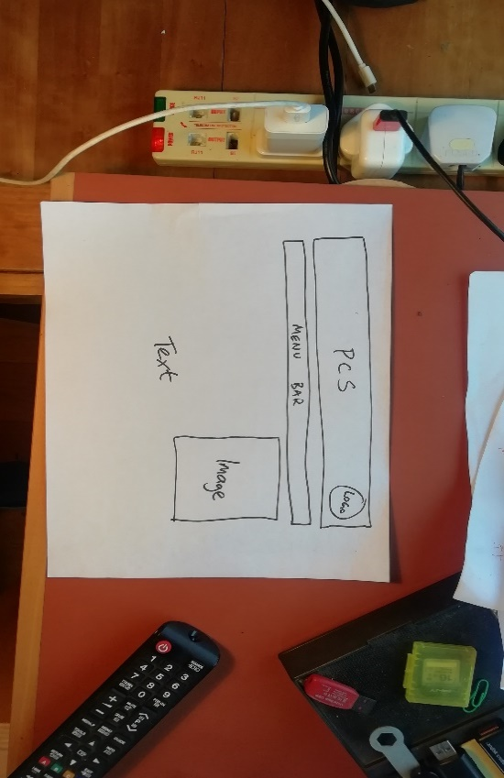

|  |  |  |
| --- | --- | --- |
| **E** | | **Certifications** |
| BBFC | U, PG, 12, 12A, 15, 18 | |
| PEGI | 3, 7, 12, 16, 18 | |

|  |  |  |
| --- | --- | --- |
| **D** | | **Data Protection Act, 1998** |
| 1 | Fairly and lawfully processed | |
| 2 | Processed for limited purposes | |
| 3 | Adequate, relevant and not excessive | |
| 4 | Accurate | |
| 5 | Not kept for longer than necessary | |
| 6 | Processed in line with your rights | |
| 7 | Secure | |
| 8 | Not transferred to other countries without adequate protection | |

|  |  |
| --- | --- |
| **C** | **Risk Assessments: Contents** |
| Working at heights | |
| Slips, trips and falls | |
| Manual handling | |
| Cable safety | |

|  |  |  |
| --- | --- | --- |
| **A** | **Health and Safety: Key Vocab** | |
| **Risk Assessment** | | An examination of the risks and an attempt to mitigate against them |
| **Mitigate** | | Take steps to avoid something bad |
| **Recce** | | Visit to a location to help with planning |
| **Legislation** | | Laws |
| **Intellectual Property** | | Something non-physical which belongs to someone, *eg script, image, music, logo* |
| **Copyright©** | | Legal protection for intellectual property |
| **Trademark™** | | A word or phrase associated with a company |
| **Registered Trademark®** | | A trademark which has been registered, meaning misuse of it could be against the law |
| **Defamation** | | Bringing someone’s reputation into doubt. This can be illegal, and the offender can be sued |
| **Slander** | | Defamatory words which are publicly spoken |
| **Libel** | | Defamatory words which are written and published |
| **Certification** | | The minimum age a film or game is suitable for |
| **Copyright, Designs and Patents Act, 1988** | | Legislation which protects intellectual property by banning its unauthorised copying or redistribution |
| **Creative Commons** | | Organisation which issues licences which allow the public partial or total access |
| **Licence** | | A legal agreement about how an asset can be used or distributed |
| **Public Domain** | | Intellectual property with no copyright which is free for anyone to use |

|  |  |  |
| --- | --- | --- |
| **B** | | **Risk Assessments: Purpose** |
| 1 | Identify the hazards | |
| 2 | Identify who is at risk | |
| 3 | Identify the severity of the risks | |
| 4 | Help mitigate against risks | |
| 5 | Provide a record of what has been done | |

R081: Health and Safety

Name:

|  |  |  |  |
| --- | --- | --- | --- |
| **C** | **Example** | | |
| **Question**  Below is a visualisation diagram for a new website for PCS. Discuss the suitability of the diagram. [12] | | **Answer**  One strength4 of the visualisation diagram is that it clearly shows the web designer1 the layout3 of the title and menu bar4. This will help her know how to arrange the web page2,9.  One weakness5 is the font7 is not specified, so the web designer1 will not know which font to use9. To improve6 this, annotations7 could be included. | |
| 1Target Audience  2Purpose  3Content  4Strength  5Weakness | 6Areas for improvement  7Technical vocab  8Specific  9Explanation |

|  |  |  |  |
| --- | --- | --- | --- |
| **A** | | **Evaluating Pre-Production Documents** | |
| **1** | **Target Audience** | | Don’t get confused between the target audience of the document and the target audience of the product |
| **2** | **Purpose** | | When you are explaining a strength, weakness or improvement you must show you understand the purpose of the document |
| **3** | **Content** | | You must know what is normally in this type of document |
| **4** | **Strengths** | | It may be very bad, but it will still have strengths. Make sure you mention them and explain them |
| **5** | **Weaknesses** | | Weaknesses are not the same as areas for improvement. Address them separately and explain them both |
| **6** | **Areas for improvement** | |
| **7** | **Technical vocabulary** | | Use a lot of the key vocab words on these organisers. |
| **8** | **Be specific** | | Show a detailed understanding of the scenario you are discussing |
| **9** | **Explain each point** | | Explanations should always refer to the target audience and the purpose of the pre-production document |

|  |  |  |
| --- | --- | --- |
| **B** | **Key Vocab** | |
| **Discuss** | | Evaluate, and give reasons for each of the points you are making. Write several paragraphs |
| **Suitability** | | How well something does its job |
| **Target audience of the document** | | The pre-production document will normally be aimed at a member of a production team – camera crew, client, script writer etc – not the general public |
| **Target audience of the product** | | The product will be aimed at a certain demographic of the general public |

Name:

R081: Evaluation of Pre-production Documents